AN459
Restoring Your Front Rubber Suspension Parts
(while you have your eng/trans out)

After all the years of wear, tear and just resting it could be time to go ahead and restore your front suspension. It doesn't take that much time once the engine and transmission has been removed. It also affords an opportunity to check out for any rust areas that should be taken care of.

1. Jack the front end up and secure with jacks. Remove the wheels.

2. Remove the ball joint at the steering knuckle (Fig. 2 @ #9). A few hits after the bolt has been loosen up will help break it loose. If your unsuccessful back the nut down so the head covers the end of the threads, with a wooden block a couple blows from this end may help.

3. Remove the coil spring (Fig. 1 @ #1), this requires a spring compressor. The SAAB factory tool is available from the NESC as a loner you may inquire. Caution should be observed as a tremendous force exist in this spring under compression.

4. Remove the shock absorber.

5. Remove the bolts (4/side) on the upper and lower A-Arms (fig.2 @ #34 and #38), slide out and remove the brake hose connection. The inner drive shaft will fit thru sheet metal.

6. Remove the Lower A-Arm (fig. 2 @ # 19) 4 nuts and washers.

7. Remove the Upper A-Arm (fig. 2 @ # 18) 4 bolts and washers. If you make note and identify the number of shims (fig. 2 @ # 32) you'll be at a starting at a good point on the alignment.

8. If your suspension has the early bushings (fig. 2 @ # 28 and # 29) these will be of split design. The split design is easily removable. The solid design may have to be taken to your machine shop to be pressed out.

9.If your painting and undercoating as you go along the upper stop bushing (fig. 1 @ # 5) is removable but can be stubborn. A large adjustable vise grip will get the job done. Grip it on the top edge, it looks like a washer.

10. If the metal retainer and rubber cushion didn't come down when you removed the coil spring it can be taken off now.

11. Another rubber cushion that should be replaced is (fig. 1 @ # 6). Their is a total quantity of 4.

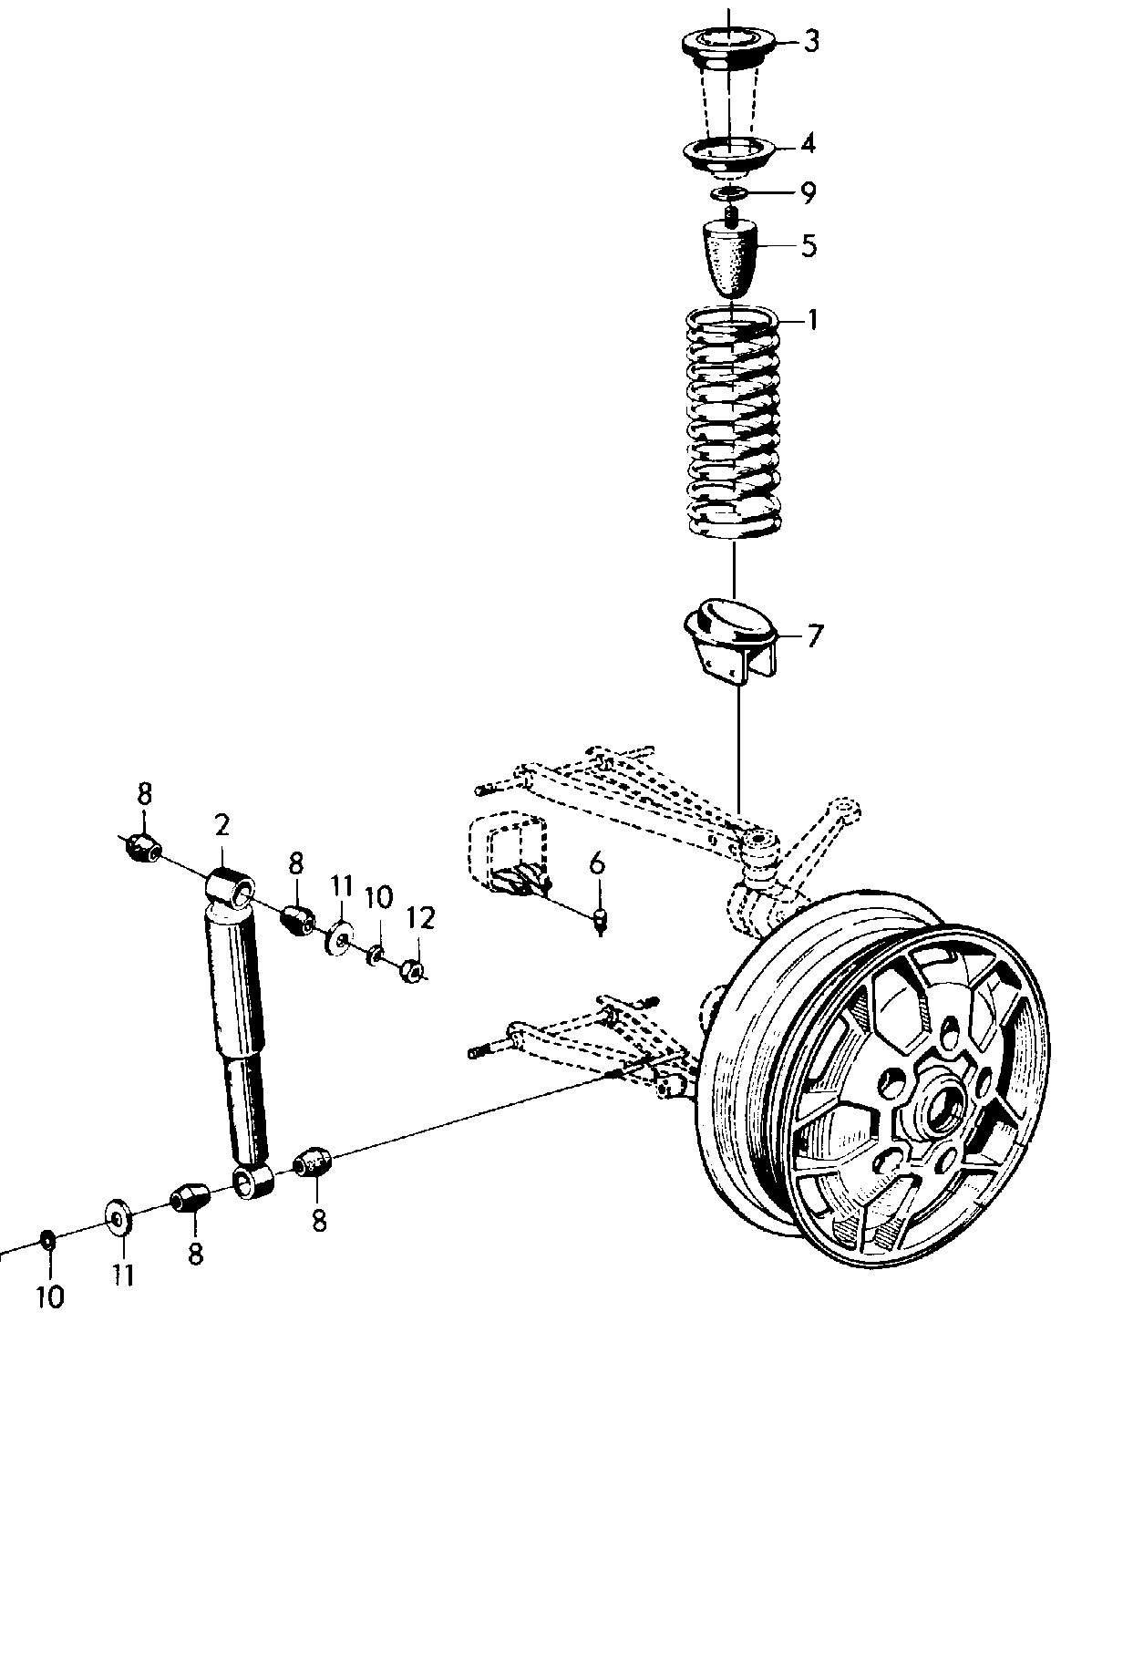
Figure 1

12. If you are removing rust and plan on painting I have used PPG's Epoxy Primer (2 part) with very satisfactory results. Check the upper and lower A-Arms out to make sure they are straight.

13. Using silicon grease you can install the new rubber bushings for the A-Arms. You can tell if you have silicon grease because it is clear and a small tube (size of a tooth paste sample) is $5.00 easily. Don't use silicon spray. These can be installed with a regular vise and some sockets to hold and push them in place. If your not able to do this the machine shop can do this quickly for you.

14. Before installing any new rubber item be sure to use a rubber protectant similar to Armour All.

15. I'd recommend replacing the lower ball joints as well as the steering ball joint.

16. The inner and outer drive shaft boots can be replaced easily when your doing this work. I'll cover that in another article.

17. Reassemble in the reverse order. If you do repaint your suspension I can tell you from experiance that the SAAB compression tool used for the spring will chip you paint very little while compressing it. You can touch this up very easily.

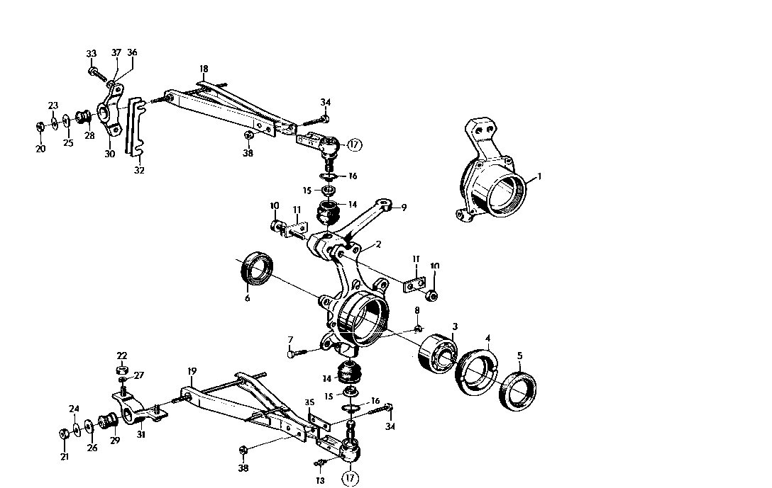
Figure 2

